Expired Materials Handling Procedures

Intro: Handling of materials is done through registering and maintaining deposits.

1. Expiration date should be a required filed when purchased materials are being registered in the warehouse in the form of the deposit. (In case where expiration date doesn’t exist it would be advisable to set it to the date far in the future, for example like year 2050 )
2. User should be able to exclude any deposit from “Expiry” process.

To remove expired materials from circulation following procedures have to be developed:

1. Warehouse manager (or any other user authorized to access Warehouse Tab) navigates to “EXPERATION” tab.
2. User generates a list of expired materials that have expired and approach expiry in user selected (dropdown) number of days).

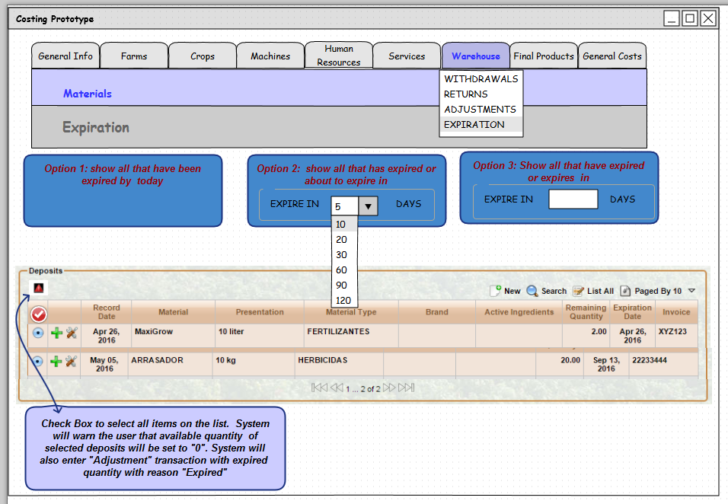

***Figure 1.***

1. User had choice to “Expire” all materials at once or individually. System will prompt user to “ACCEPT” or “CANCEL” (see Figure 2 and Figure3)

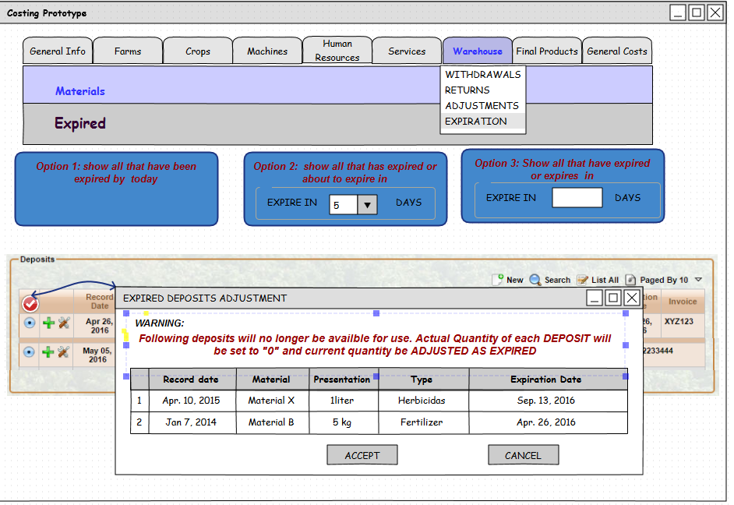

***Figure 2***

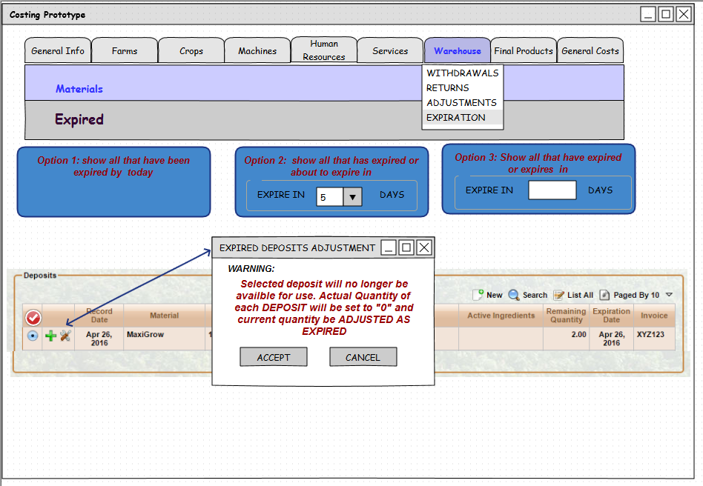

***Figure 3***

1. System will enter "Adjustment" transaction with expired  quantity with reason "Expired"

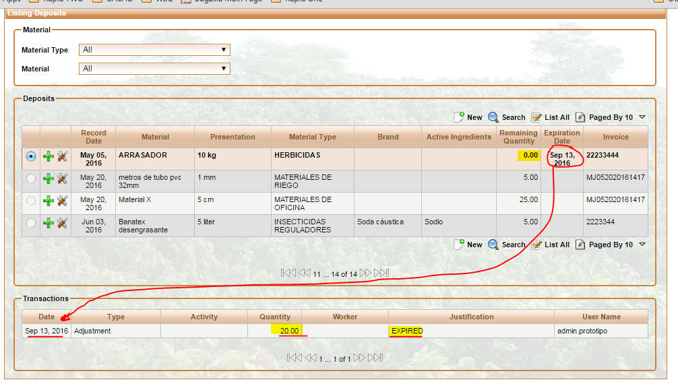

***Figure 4.***